- MobileNetV2
Training Accuracy: 98.76%
Validation Accuracy: 64.06%
Testing Accuracy: 63.38%
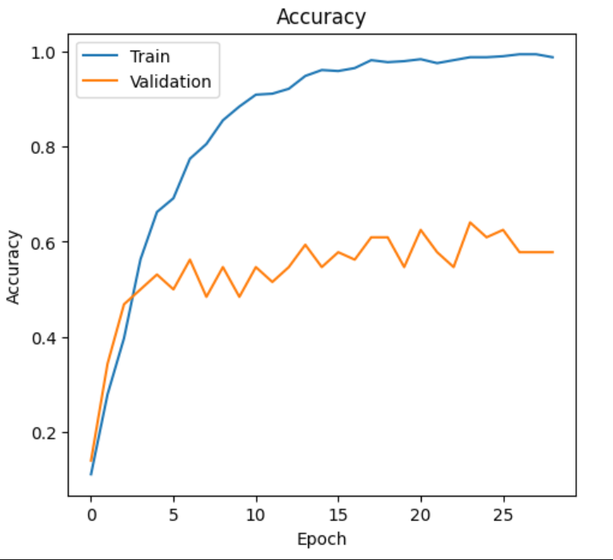
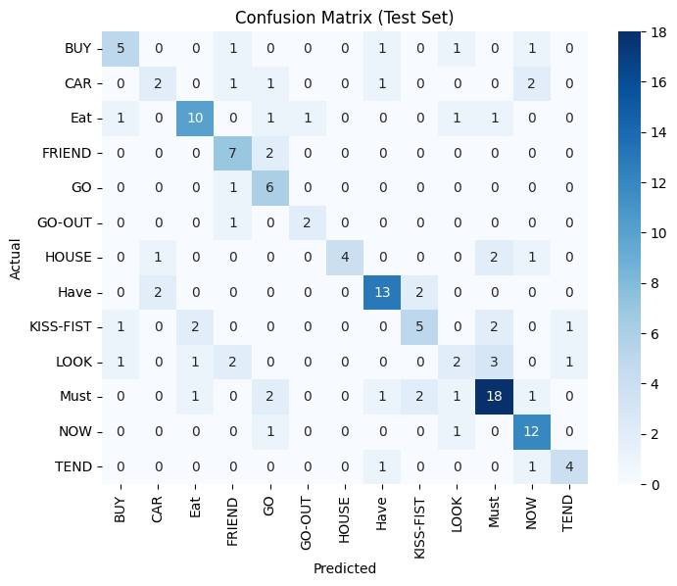

- EfficientNet b0
Training Accuracy: 96.89%
Validation Accuracy: 52.899% (I average epoch 20-30 val accuracy)
Testing Accuracy: 57.14%
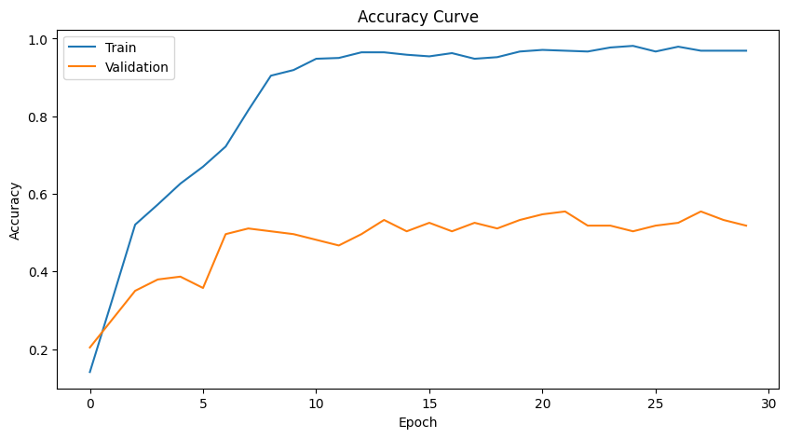
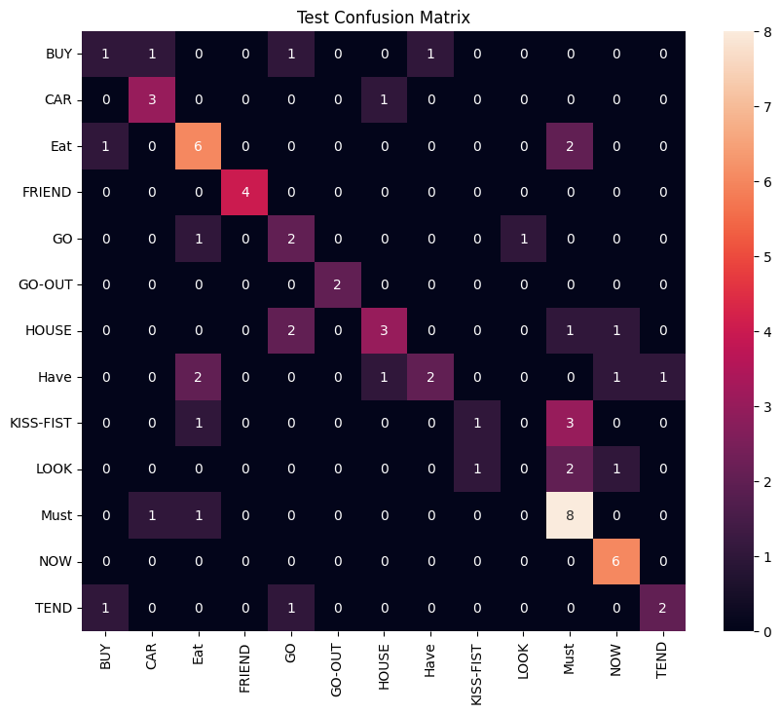

- Resnet-18
Training Accuracy: 99.59%
Validation Accuracy: 54.74%
Testing Accuracy: 54.29%
